Ideation Phase
Empathize & Discover

Date | 15 july 2026
Team ID | SWTID-2026-9567
Project Name | AI Powered Debt Relief & Financial Recovery Platform
Maximum Marks

Empathy Map Canvas:
An Empathy Map helps understand the needs, emotions, behaviors, and challenges of borrowers who are struggling with debt management and financial recovery. By understanding the user's perspective, the team can design an AI-powered solution that provides personalized financial guidance and improves decision-making.

Reference: https://www.mural.co/templates/empathy-map-canvas

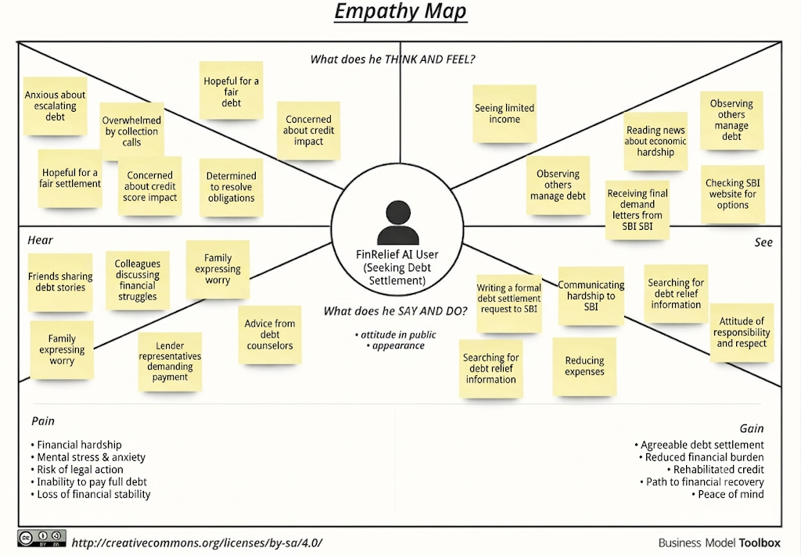

👤 User
Target Users: Borrowers, salaried employees, self-employed individuals, families managing multiple loans, and users seeking financial recovery assistance.

💭 Think & Feel
Worried about increasing debt and monthly EMI payments.
Wants to become financially stable.
Needs trustworthy financial advice.
Seeks an easier way to manage multiple loans.
Wants personalized repayment guidance.

👀 See
Loan repayment reminders and credit card bills.
Rising living expenses and interest rates.
Financial planning apps and budgeting tools.
Bank notifications and loan offers.

👂 Hear
Advice from family and financial advisors.
Suggestions from banks and lenders.
Financial tips from social media and online articles.
News about economic conditions and interest rates.

🗣️ Say & Do
Tracks monthly income and expenses.
Searches online for debt repayment methods.
Compares loan interest rates.

Plans budgets to reduce unnecessary spending.
Looks for AI-powered financial assistance.

😟 Pain Points
Managing multiple loans is difficult.
High interest rates increase repayment burden.
Lack of personalized financial guidance.
Financial stress and uncertainty.
Fear of missing EMI payments and lowering credit score.

🎯 Gains
AI-powered debt repayment recommendations.
Better budgeting and expense management.
Personalized financial recovery plans.
Reduced financial stress.
Improved savings and financial stability.
Better long-term financial planning.

